|  |
| --- |
| genweb2 ltd. |
| Samuda HR Leave Request User Manual |
| REFERENCE: GW/ERP/USER MANUAL |
|  |
| **Genweb2 Ltd.** |
| **10-Jul-17** |

|  |
| --- |
| logo.png  **Genweb2 Limited**  TK Bhaban (11th Floor),  13 KaziNazrul Islam Avenue,  Kawran Bazar, Dhaka 1215, Bangladesh  web: [http://www.genweb2.com](http://www.genweb2.com/) |

Contents

1. HR Leave Management 3

1.1 Create Leave Types 3

1.2 Create Leave Years 4

1.3 Create Leave Allocation 5

1.4 Create Leave Request 6

1.5 Show Leave Summary 10

1.6 Create Leave Allocation Request 11

# 1. HR Leave Management

HR Leave Management allows employees to request leaves. Then, managers can review requests for leaves and approve or reject them. This way we can control the overall leave planning for the company or department.

We can configure several kinds of leaves (sick leave, casual leave, unpaid, compensatory Days) and allocate leaves to an employee or department quickly using leave allocation. An employee can also make a request for more days off by making a new Leave allocation. It will increase the total of available days for that leave type (if the request is accepted).

**How to install this Module:**

In order to make use of Leave Management features, user needs to install Leave module respectively which can be located in Local Modules under Settings menu.

## 1.1 Create Leave Types

First we need to create leave type. We can configure several kinds of leaves like sick leave, casual leave, unpaid, compensatory days etc. This leave types menu allow HR manager to create and configure all leave types that will be required to approve leave and process it. It will be visible on leave request form.

Using the menu **Leave ‣ Configuration ‣ Leave Types** and click **Create**

You need to configure the following:-

**Leave Type**: Select a Leave Type.

**Apply Double Validation:** If we want double approval then check the Apply Double Validation check box otherwise uncheck.

**Allow to Override Limit**: If we want override leave limit then check Allow to Override Limit check box otherwise uncheck.

**Active:** If we want active the live type then check the Active check box otherwise uncheck.

**Color in Report:** Choose a Color for report.

**Company**: Select a Company.

After entering the Leave Types information click **Save**.

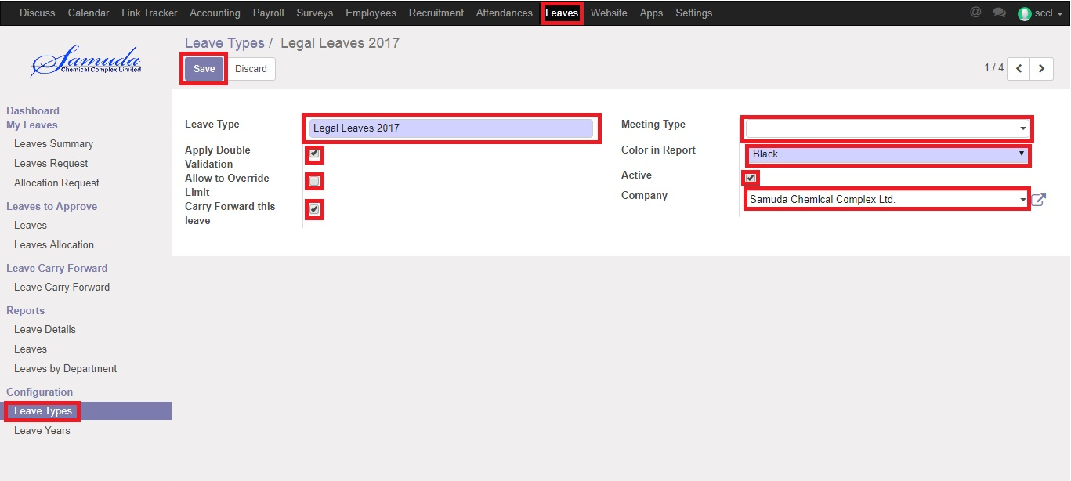

Figure: Create a Leave Type

## 1.2 Create Leave Years

This leave years menu allow HR manager to create and configure all leave years that will be required to approve leave and process it. It will be visible on leave request form. For create leave years we need to go configuration menu.

Using the menu **Leave ‣ Configuration ‣ Leave Years** and click **Create**

You need to configure the following:-

**Fiscal Year**: Enter a Fiscal Year.

**Code:** Enter a Fiscal Year.

**Start Date**: Choose a Start Date.

**End Date:** Choose an End Date.

After entering the Leave Years information then create monthly periods or create 3 months periods click **Save**.

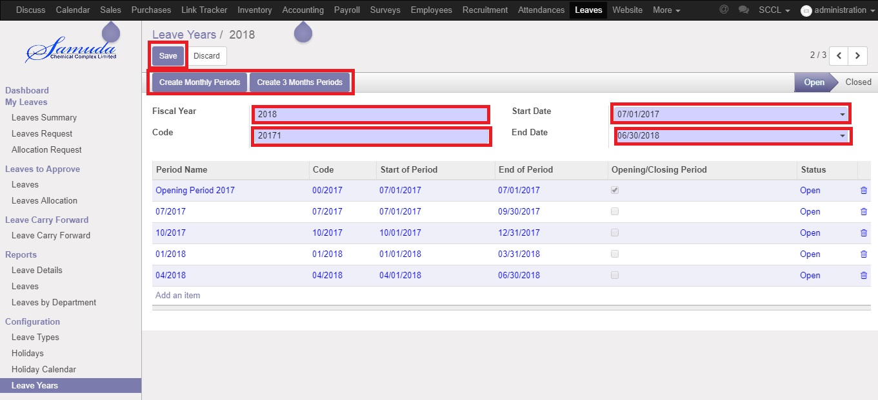

Figure: Create a Leave Year

## 1.3 Create Leave Allocation

This leave allocation menu allow HR manager to create and configure all leave allocation that will be required to approve leave and process it. It will be visible on leave request form.

Using the menu **Leave ‣ Leave to Approve ‣ Leave Allocation** and click **Create**

You need to configure the following:-

**Description**: Enter some description for leave request.

**Leave Type:** Select a leave type.

**Leave Year**: Leave year is selected automatically.

**Duration:** Enter duration.

**Mode:** Select a mode.

**Employee**: Choose an Employee.

After entering the Leave Allocation information then click **Save**.

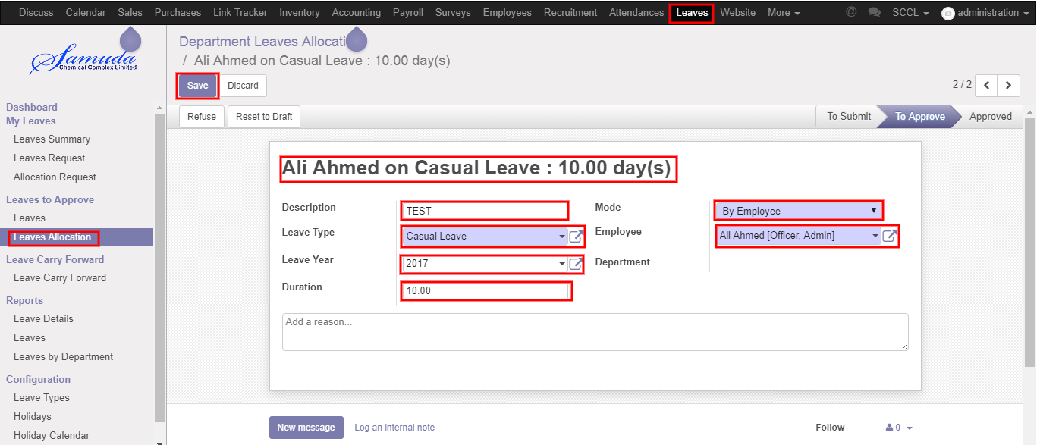

Figure: Create a Leave Allocation

## 1.4 Create Leave Request

For create a leave request we have to go leave menu then create a leave request. Department manager or HR Manager can leave request for himself and every employee. Then DM can give first approval or can refuse and HRM can give last approval.

Using the menu **Leave ‣ My Leaves ‣ Leave Request** click **Calendar** button.

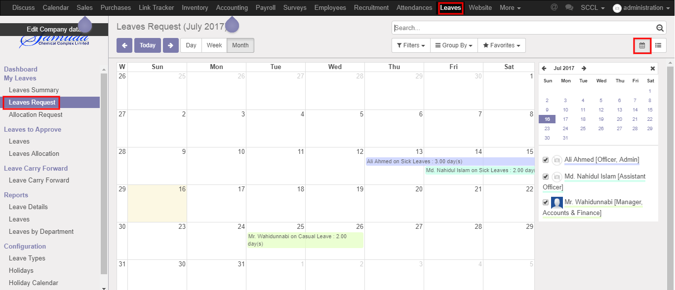

**Fig:** Leave Calendar View

Using the menu **Leave ‣ My Leaves ‣ Leave Request** click **List** button.

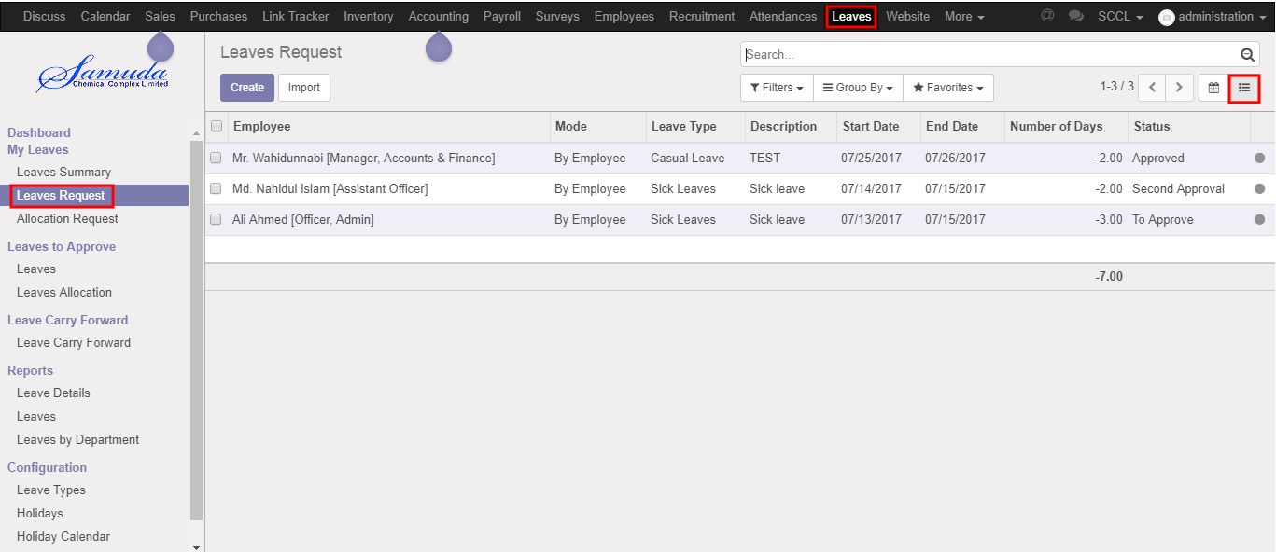

Figure**:** Leave List View

Using the menu **Leave ‣ My Leaves ‣ Leave Request** click **Create**.

You can set the following information:-

**Description:** Enter some description.

**Leave Type:** Select a leave type.

**Duration:** Select duration of leave.

After entering the Leave Request information click **Save**.

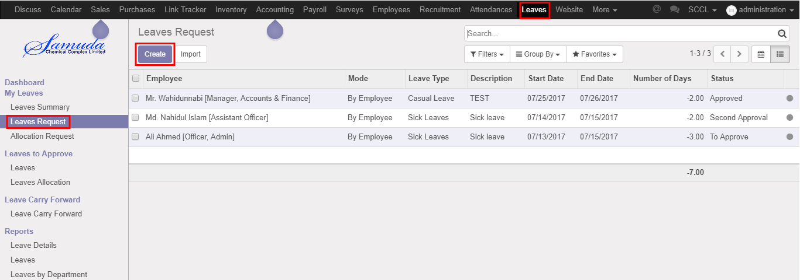

Figure: Create a Leave Request

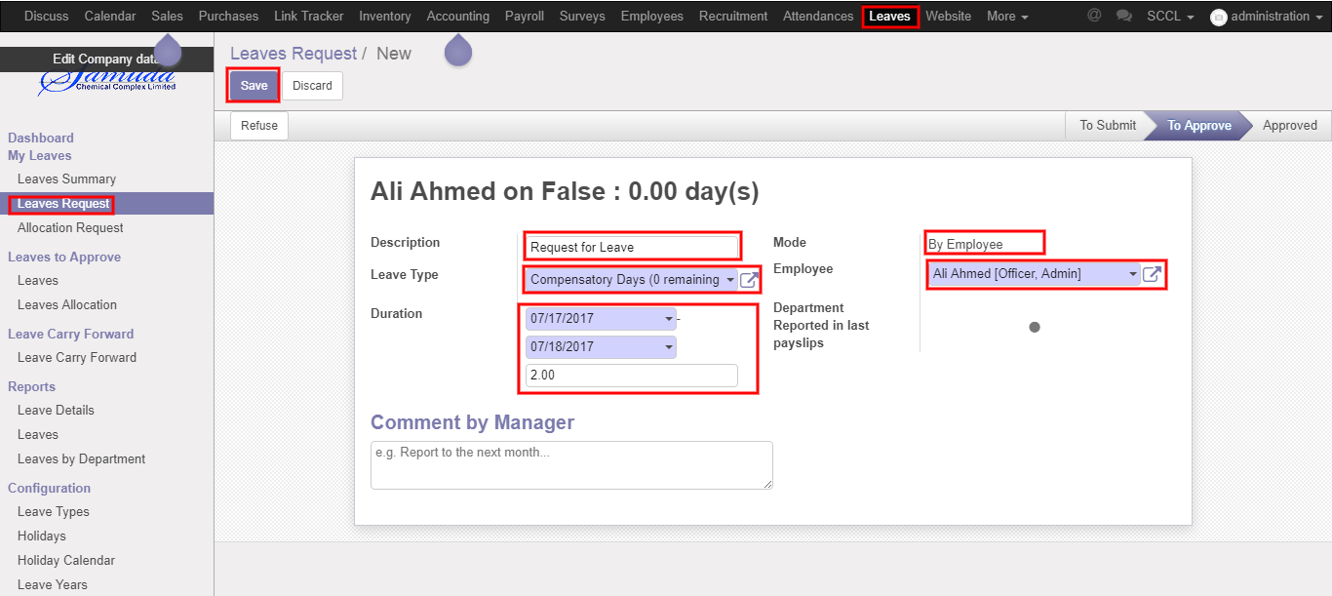

Figure: Create a Leave Request

After apply the leave request “Department Manager & Manager” will get the notification. Department Manager can first approve the leave request. He can update number of leave day(s) before approval. After Department Manager Approval, HR will get notification. HR Manager Can Approve or Refuse the leave request. After that requested leave will finally approve.

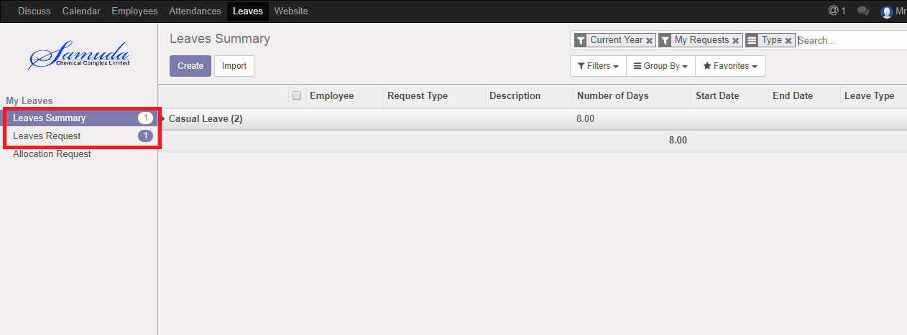

Figure: Leave Request Notification

Department manager can approve employee’s leave request. DM and HRM can see all leave request there **Leave ‣ Leave to approve ‣ Leaves.**

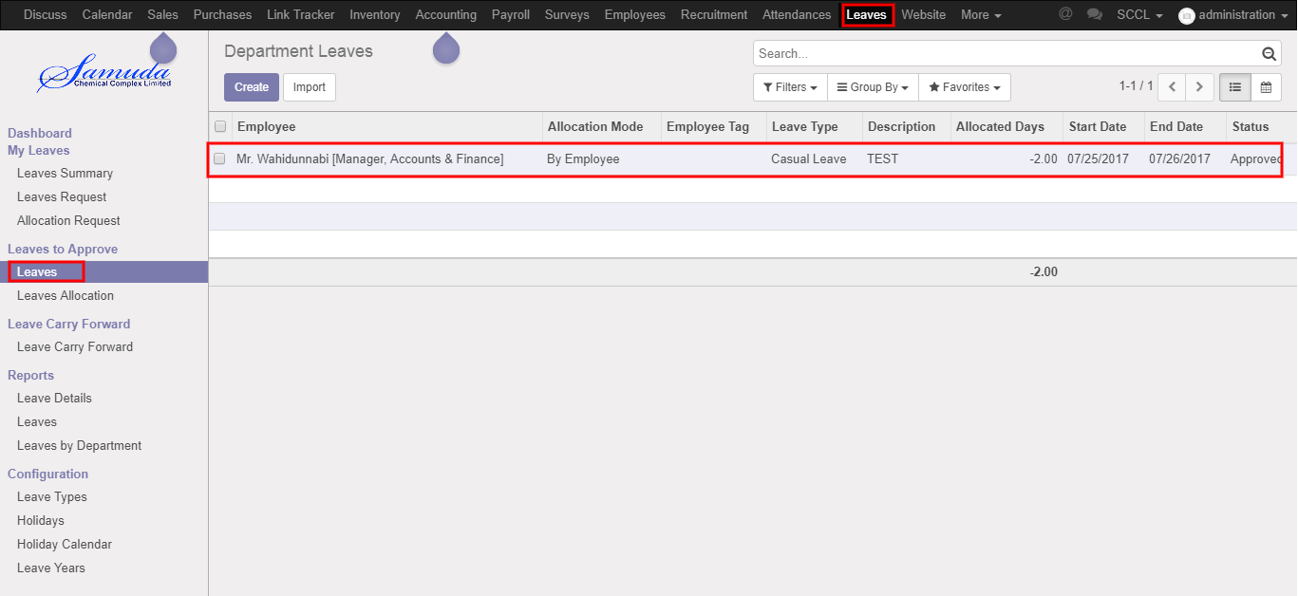

Figure: All Leave Request List View

Here Department Manager can first approve the leave request by click on Approve button. He can update number of leave day(s) before approval.

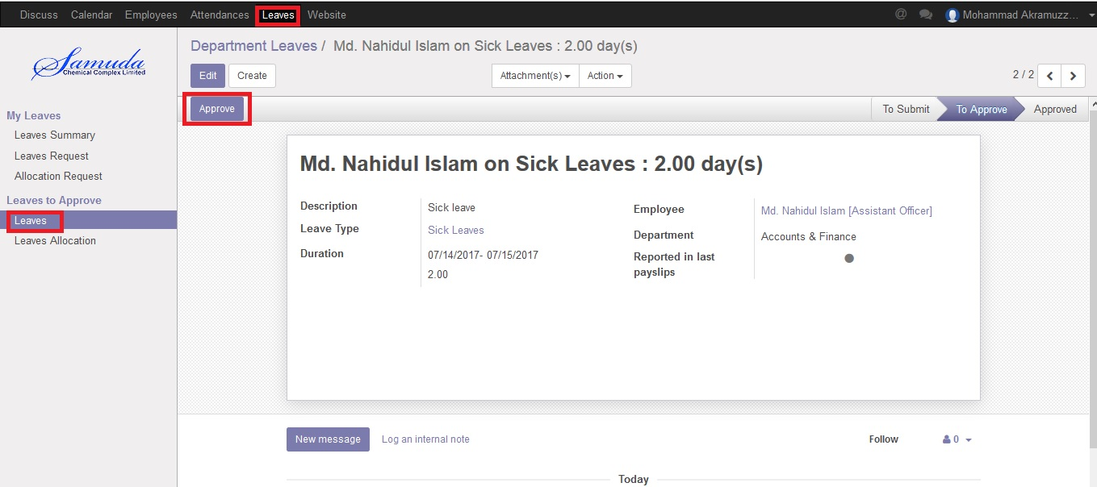

Figure: All Leave Request First Approval

After Department manager’s approval HR manager can final approve or refuse the employee’s leave request. DM and HRM can see all leave request there **Leave ‣ Leave to approve ‣ Leaves.**

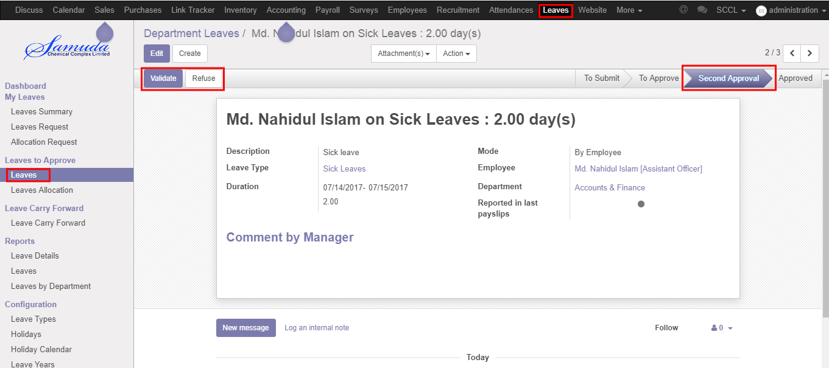

Figure: All Leave Request Second Approval

## 1.5 Show Leave Summary

For create a leave request we have to go leave menu then create a leave request. Department manager and HR manager can see all of employee leave Summary.

Using the menu **Leave ‣ My Leaves ‣ Leave Summary**.

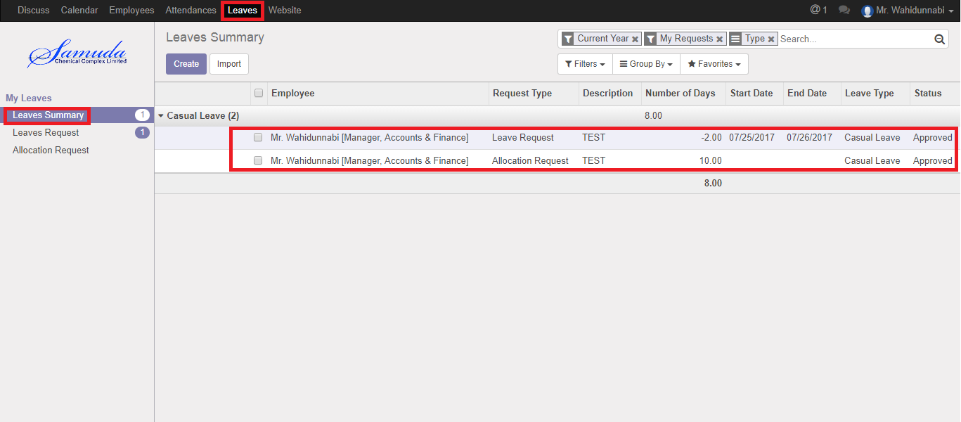

Figure: Leave Summary

## 1.6 Create Leave Allocation Request

For create a leave allocation request we have to go leave menu then create an allocation request. Department manager or HR Manager can leave allocation request for himself and every employee. Then DM can give first approval or can refuse and HRM can last approval.

Using the menu **Leave ‣ My Leaves ‣ Allocation Request** click **Create**.

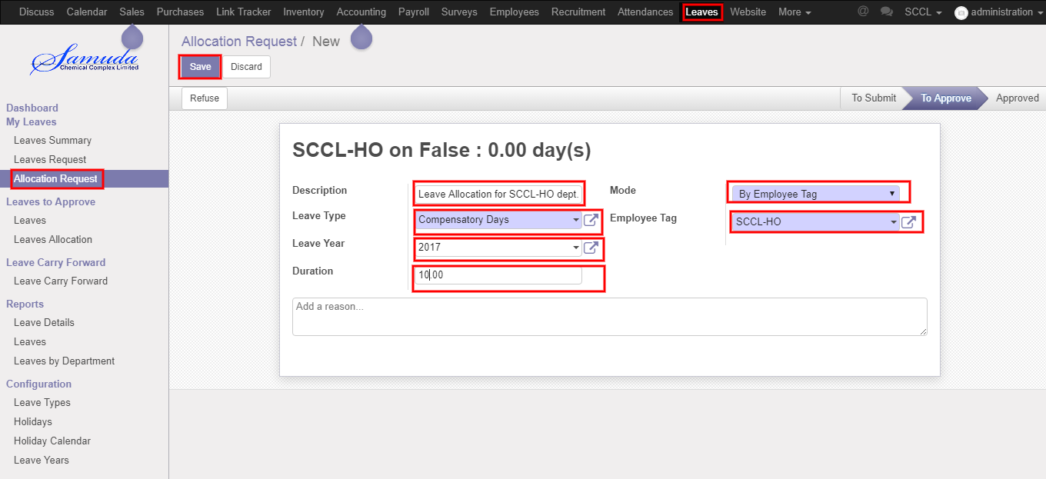

Figure: A Leave Allocation Request

After apply the leave allocation request “Department Manager & Manager” will get the notification. Department Manager can first approve the leave allocation request. He can update number of leave day(s) before approval. After Department Manager Approval, HR will get notification. HR Manager Can Approve or Refuse the leave allocation request. After that requested leave will finally approve.

Here Department Manager can first approve the leave request by click on Approve button. He can update number of leave day(s) before approval.

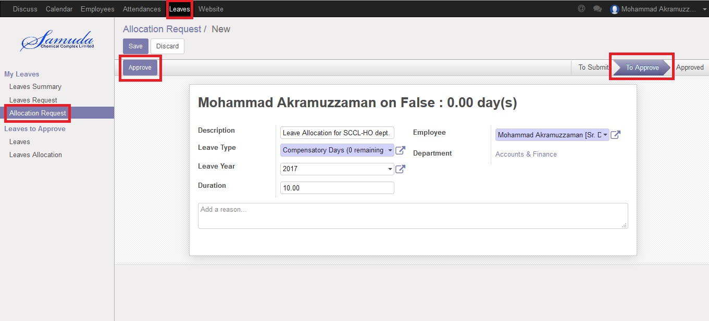

Figure: All Leave Allocation Request First Approval

After Department manager approval HR manager can final approve or refuse the employee’s leave allocation request. DM and HRM can see all leave allocation request there **Leave ‣ Leave to approve ‣ Leaves Allocation.**

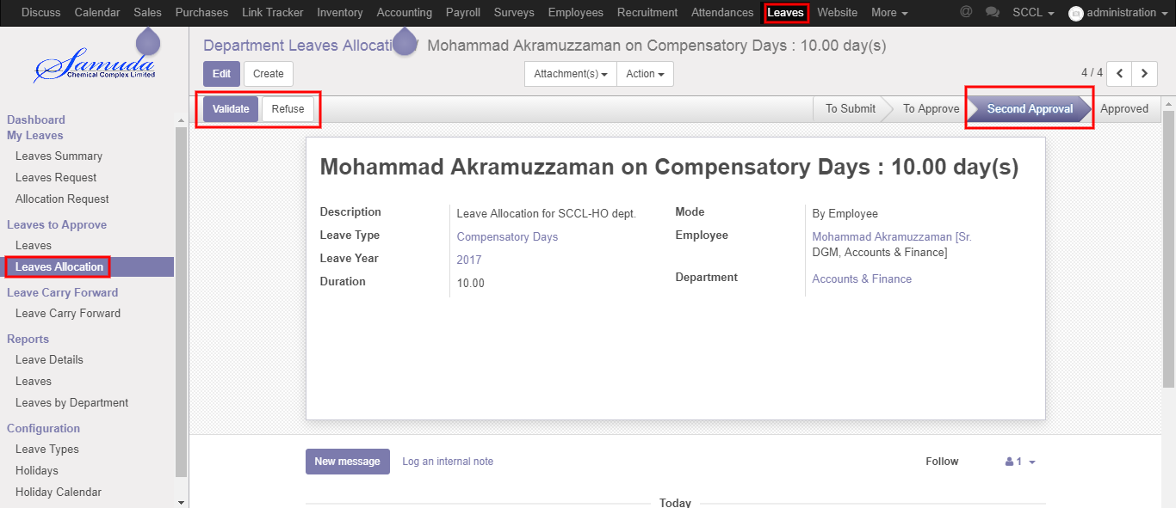

Figure: All Leave Allocation Request Second Approval